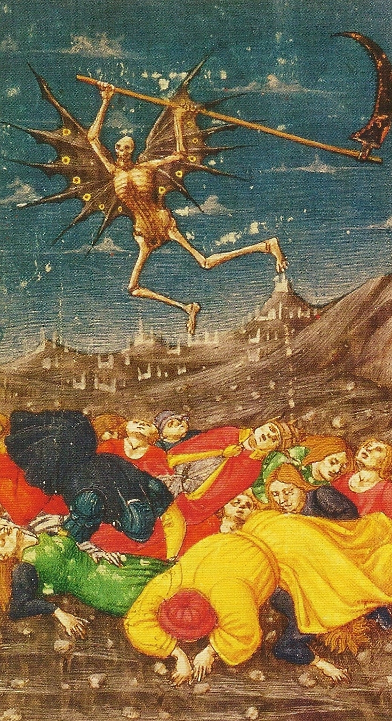
Study morning
The Plague Years: No Triumph, No Tragedy
Imogen Corrigan
The effects of the C14th plague known as the Black Death.
The chroniclers’ response.
Changes in society: what happens when at least 50% of the population perishes in about 18 months?
Monday 4 March 10.00-12.30
Westerham Hall
Cost £5
Session 1 : 10.00 -11.00

Coffee and biscuits: Provided by Courtyard Kitchen @ £1.50

Session 2 : 11.30 -12.30

——————————————————————————————————

I / we would like to attend the study morning on Monday 4 March 10.00-12.30 in Westerham Hall.

I enclose a cheque / cash for £5 per person. Please send cheques payable to
Westerham U3A Outings Account
c/o
Tina Rhoda. South View, Old Lane, Tatsfield, TN16 2LJ

If you wish to transfer payment, please use these details:
Sort code: 60-19-02
A/C : 23216417
Payment reference: Name + Study day

Signed…………………………………….. Print name………………………….

