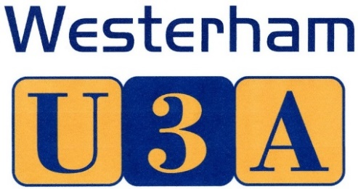

18 June 2015

Press release – for immediate distribution

Captain Eric ‘Winkle’ Brown CBE to speak at Westerham U3A

New study groups – Mahjong to Military History

Westerham U3A will welcome Captain Eric ‘Winkle’ Brown CBE, DSC, AFC as speaker at its next Open Meeting, to be held at 2pm in Westerham Hall on Thursday 9 July 2015. Former Royal Navy test pilot extraordinaire, Captain Eric Brown holds two of the most remarkable records from the world of flying, including having flown 487 different aircraft. Now in his 90s, the Captain will talk about his life and heroic WW2 adventures, and how he holds the world record for the most aircraft carrier landings performed (2,407). He also tested the first British jets.

Social Secretary Tina Rhoda said: ‘We are so fortunate to have such a fascinating speaker and we hope to welcome a number of non-members to our July meeting – they can also find out what our U3A is all about. Each month, Westerham U3A invites speakers on all sorts of subjects – magic in September and the Magna Carta in October, for example. And there’s visits, outings and a range of interest groups on offer.’

Members have a choice of all sorts of subjects to study – among those recently added are Mahjong and Military History. Chairman Lyn Snowden says: ‘With Westerham U3A, you can find out more about science, brush up on French, Italian or Spanish, share your appreciation of great paintings and brilliant books, or just join a convivial group for Sunday lunch or rambling. Our U3A offers some amazing opportunities for people who are no longer in full time employment to keep active – mentally and physically!’

For more information about Open Meetings, study groups and becoming a Westerham U3A member, see www.westerhamU3A.org or email WesterhamU3A@hotmail.co.uk

Ends
Editors’ notes:

- Captain Brown featured in the BBC programme ‘Britain’s Greatest Pilot’ and is author of the autobiographical book Wings on my Sleeve – among others. He also met Churchill twice, was arrested by the SS and interrogated Goering.
- Westerham U3A is an educational charity that promotes life-long learning for those retired/no longer in full-time employment (no lower age limit). There are no exams or educational requirements. Group leaders are unpaid volunteers.
- JPEGs of U3A groups, meetings and logo are available
- Membership costs £20* pa (£35 for joint membership) plus e.g. tea and coffee/room hire charges. There is no charge for attendance at Open Meetings, to which non-members can come on up to three occasions.
- Westerham U3A’s second AGM will also be held at the July meeting – non-members cannot vote.

Press contact: Louise Wood 07824 994690

