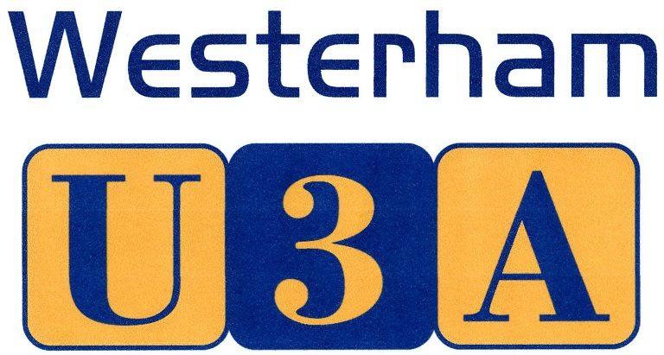

30 March 2017

Press release – immediate distribution

To Islam via Africa … Westerham U3A’s latest Open Meetings
Volunteering in Malawi – 13 April 2017
Islamic Art – 11 May 2017

The next Open Meetings in Westerham U3A’s 2017 calendar are on two very different subjects - the first is about taking books to remote areas of SE Africa, and the second compares and contrasts Islamic and Christian art, while asking ‘whose God is it anyway?’

Local ex-teacher, Tina Rhoda’s talk on Volunteering in Malawi (2pm, Westerham Hall, 13 April), takes the audience to one of the world’s poorest and least developed countries. “I wanted a different type of holiday,” Tina explains, “and found The Book Bus, a charity that provides mobile libraries for remote communities. We went into schools to do group work with children.”

“On our second visit, we helped teachers establish a reading room, as there were no books in the school. We were teaching in English and our fabulous translators translated into the native Chechewa. The children were so lovely, so enthusiastic and really wanted to learn …”

May’s speaker, Imogen Corrigan, explains that the art and architecture of Islam is often held to be very different from that of the west, bound by rigorously enforced rules. She asks “is that true, or maybe the two cultures have borrowed from and influenced each other in more ways than one might imagine”.

As well as the monthly talks (at which non-members are welcome), the charity runs a wide variety of interest groups, regular events, outings and social activities. There is a choice of some 35 interest groups available to U3A members, on subjects as diverse as bridge and books, walking and wine appreciation.

Details about Westerham U3A can be found on the website www.westerhamU3A.org where there is also information on how to join – it is open to anyone no longer in full time employment. Annual membership costs just £20 (£35 for a joint membership).

Future programme

Date Speaker Subject
13 April Tina Rhoda Volunteering in Malawi
11 May Imogen Corrigan Islamic Art
8 June Mary Forlenza Great Lovers
13 July Geoff Green 50 years of collecting autographs
10 August Tea at Titsey Place
14 September John Halligan Diarist Samuel Pepys

Ends

Editors’ notes:

Westerham U3A is an educational charity that promotes life-long learning for those retired/no longer in full-time employment in Westerham and the surrounding area – there are no age limits, no exams and no entry requirements. Group leaders are unpaid volunteers and members can join as many of the available study/interest groups as they wish. A small charge is sometimes levied towards venue hire or consumables.

It is part of a network of 1,000+ local U3A groups in the UK, with a nationwide membership of 383,000+. More about the U3A movement can be found at www.U3A.org.uk

Picture captions: Tina Rhoda teaching children in Malawi (low resolution version only available)
Examples of Islamic art
Press contact: email westerhamU3A@hotmail.co.uk f.a.o. Louise Wood m: 07824 994690

